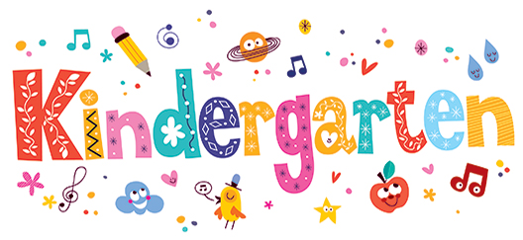

**Hello!**

My name is Mrs. Childs. I am so excited to meet all of you! This will be an exciting year filled with lots of new friends, adventures, and learning. This will be my first year teaching and I look forward to growing alongside of you.

In this classroom you are cared about. My goal is to encourage you to be the best person you can be and support you in every way. I promise to do my best to help you learn and grow both inside the classroom and outside the classroom. You have wonderful gifts, strengths, and talents and I can’t wait for you to share them with your classmates and I. You are uniquely and wonderfully you!

**Contact me**

Please feel free to contact me throughout the school year. I want to be your partner in supporting your child in any way. Feel free to email me at any time as well.

**Email – ChildTo@boe.richmond.k12.ga.us**

**Room - 205**

**Welcome to**